AskMeOffers Chrome Extension Test Report

Prepared by: Mahima Kumari

Date: 26-04-2024

| **Table of Contents** |
| --- |
| Introduction |
| Test Report |
| Improvements |
| Conclusion |

## **1. Introduction**

The purpose of this document is to outline the testing efforts conducted on the Askmeoffers Automatic Coupon Chrome Extension. This extension is designed to provide users with automatic coupon suggestions during online shopping sessions. The scope of testing includes installation, functional, and performance testing to ensure the extension's reliability and efficiency

## **2. Test Report**

**Installation Testing**

* Tested installation from Chrome Web Store and manual installation via extension files.
* Ensured compatibility across multiple browsers and operating systems.
* Verified error-free installation without conflicts or permission issues.

**Functional Testing**

* Tested all features of the "Ask Me Offers" extension, including:
  + Applying coupons on multiple e-commerce websites.
  + Trying to subscribe to my favorite websites.
  + Attempting to log in to the extension using various methods, etc.
* Verified user interactions and interface responsiveness.
* Checked error handling and feedback for invalid cases.

**Performance Testing**

* Conducted load testing of the Chrome extension using JMeter.
* Measured load time and CPU utilization while the extension was running.

| **Test Case ID** | **Test Case Description** | **Test Status** |
| --- | --- | --- |
| **Installation Tests** | | |
| TC_INST_001 | Verify extension installs correctly | Pass |
| TC_INST_002 | Confirm prompt handling during installation | Pass |
| TC_INST_003 | Verify extension persists after Chrome restart | Pass |
| TC_INST_004 | Simulate installation failure due to network issue | Pass |
| TC_INST_005 | Verify behavior on incompatible Chrome version | Pass |
| TC_INST_006 | Verify extension persists and functions after the browser restart | Pass |
| **Functional Tests** | | |
| TC_FUN_001 | Automatic coupon application | Pass |
| TC_FUN_002 | Correct discount calculation | Pass |
| TC_FUN_003 | Multiple coupon application | Pass |
| TC_FUN_004 | Coupon generation failure handling | Pass |
| TC_FUN_005 | Apply coupon on the unsupported store | Pass |
| TC_FUN_006 | No pop-up displayed | Pass |
| TC_FUN_007 | Network disconnection during coupon application | Pass |
| TC_FUN_008 | Online store name display | Pass |
| TC_FUN_009 | Subscribe button functionality | Fail |
| TC_FUN_010 | Open the Support Page from the Menu | Pass |
| TC_FUN_011 | Open the Legal Page from the Menu | Pass |
| TC_FUN_012 | Open the "Rate Askmeoffers" Page from Menu | Pass |
| TC_FUN_013 | Open the "Login or Enroll" Page from the Menu | Pass |
| TC_FUN_014 | Login with Email ID from the "Login or Enroll" Page | Fail |
| TC_FUN_015 | Continue with Facebook from the "Login or Enroll" Page | Fail |
| TC_FUN_016 | Continue with Google from the "Login or Enroll" Page | Fail |
| TC_FUN_017 | Continue with Apple from the "Login or Enroll" Page | Fail |

A detailed report consisting all the test cases can be found in the Excel sheet **AskmeOffers_TestCases.xlsx** attached. This sheet contains a detailed report of all tests performed and the steps to reproduce the tests. It also contains the details of whether the test cases passed.

### **Performance Testing**

Performance testing of the AskmeOffers website was conducted using Apache JMeter. The aim was to evaluate the website's performance under various load conditions and identify any performance bottlenecks.

**Test Information:**

● Source file: AskmeOffershtmlReport.csv

● Start Time: 4/26/24, 11:56 AM

● End Time: 4/26/24, 11:56 AM

**APDEX (Application Performance Index):**

● APDEX Score: 0.037

● Thresholds:

● Satisfied: 500 ms

● Tolerating: 1 sec 500 ms

● Frustrated: 1 sec 500 ms

Requests Summary:

| **Request** | **Result** | **Count** | **Error Rate** |
| --- | --- | --- | --- |
| Total |  | 100 | 80.00% |
| <https://cdn.askmeoffers.com/arrowhead_down-16.svg> | PASS | 20 | 0.00% |
| <https://cdn.askmeoffers.com/arrowhead_right-16.svg> | PASS | 20 | 0.00% |
| <https://cdn.askmeoffers.com/coupon_mini-fill-16.svg> | FAIL | 20 | 100.00% |
| <https://cdn.askmeoffers.com/flag-stroke-16.svg> | PASS | 20 | 0.00% |
| <https://cdn.askmeoffers.com/h-16.svg> | PASS | 20 | 0.00% |
| Test |  | 20 | 100.00% |

CPU and Memory Usages from Task Mangager

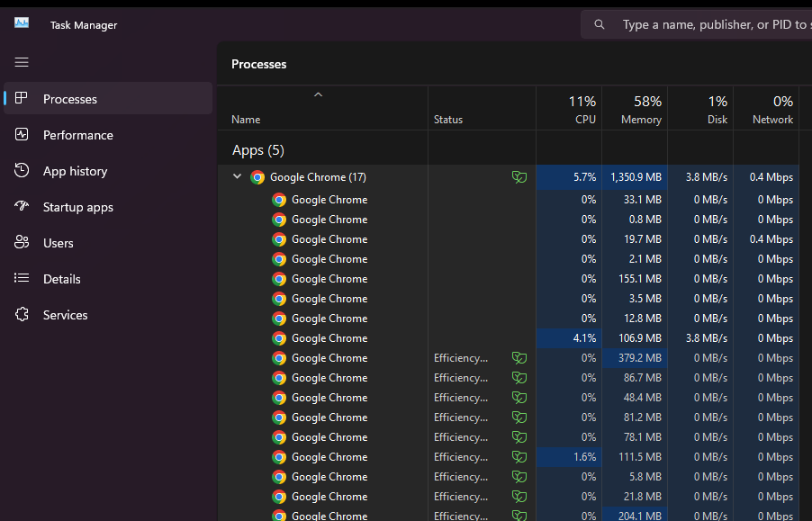

## **3. Improvements**

Currently, I have used Excel sheets to maintain the test cases. But it’s not scalable, We can use JIRA software to better track our test cases and report the issues. We can create tickets to report the issue and track the progress of the issue. It also provides the functionality of generating test reports. Which can minimize the efforts of generating QA/Test cycle reports.

We can also improve the overall testing of the extension by adding more test cases and automating some of the test cases using automation tools like Selenium.

## **4. Conclusion**

## Successful Testing Outcome:

## In conclusion, the installation, functional, and performance testing of the AskmeOffers Automatic Coupon Chrome Extension yielded positive results overall, with successful installation, functional feature validation, and satisfactory performance under load.

## Areas for Improvement:

## While the extension performed well in many aspects, identified issues such as the malfunctioning subscribe button and login/enroll functionality indicate areas for improvement to enhance user satisfaction and usability.

## Recommendations:

## Based on the testing outcomes, it is recommended to prioritize resolving identified issues, optimizing performance where necessary, and conducting further testing to ensure the extension meets user expectations and delivers a seamless experience